**FOOD TRACKING SYSTEM**

**PROJECT REPORT**

**Submitted by**

RAJAMANI RMR ( 921020104038 )

MOHAMMAD JAVID AR ( 921020104031 )

SANGILIMUTHU S ( 921020104045 )

PRAVEEN KUMAR M ( 921020104036 )

**Content**

* **INTRODUCTION**
* Project Overview
* Purpose
* **IDEATION & PROPOSED SOLUTION**
* Problem Statement Definition
* Empathy Map Canvas
* Ideation & Brainstorming
* Proposed Solution
* **REQUIREMENT ANALYSIS**
* Functional requirement
* Non-Functional requirements
* **PROJECT DESIGN**
* Data Flow Diagrams
* Solution & Technical Architecture
* **CODING & SOLUTIONING**
* Source Code
* **ADVANTAGES & DISADVANTAGES**
* **CONCLUSION**
* **FUTURE SCOPE**

GitHub & Project Video Demo Link

**INTRODUCTION**

* **PROJECT OVERVIEW**

The Food Tracking System using Blockchain is an innovative solution that leverages blockchain technology to enhance the transparency, traceability, and security of the food supply chain. This system is designed to serve various stakeholders, including food producers, distributors, retailers, regulatory agencies, and consumers. By utilizing the immutable and decentralized nature of blockchain, it aims to address issues such as food fraud, contamination, and inefficiencies within the food industry

* **PURPOSE**

The purpose of a food tracking system implemented on a blockchain is to leverage the unique capabilities of blockchain technology to enhance the transparency, traceability, and security of the food supply chain.

* **Enhanced Transparency:**

Blockchain provides a distributed ledger that records all transactions and data related to food products at every stage of the supply chain. This transparency allows all participants to see the movement of products, from their origin to the end consumer. This is particularly valuable for proving the authenticity of organic or locally-sourced products.

* **Improved Traceability:**

With blockchain, the entire history of a food product is stored immutably. This makes it easier to trace the origin of a product, identify the source of contamination in case of recalls, and ensure the authenticity of high-value goods, like premium wines or rare seafood.

* **Security and Data Integrity:**

Blockchain's immutability ensures that once data is recorded, it cannot be altered or tampered with. This is crucial for maintaining the integrity of records related to food safety and compliance with regulations.

* **Automated Compliance:**

Smart contracts, which are self-executing contracts with the terms of the agreement directly written into code, can be used to automate compliance with regulatory standards and quality control procedures. When conditions are met, smart contracts can trigger actions, such as notifications, quality checks, or even payments.

* **Efficient Recalls:**

In case of food recalls or safety concerns, blockchain enables more efficient and precise recalls. With the ability to pinpoint the exact batch or product affected, recalls can be executed quickly, reducing the risk of illnesses and waste.

* **IDEATION & PROPOSED SOLUTION**
* **PROBLEM STATEMENT DEFENITION**

The food industry faces challenges related to food safety, transparency, and traceability. Incidents of contamination, mislabeling, and lack of visibility into the supply chain have raised concerns among consumers and regulators. There is a need for a system that can provide real-time, transparent, and secure tracking of food products from farm to table.

* **EMPATHY MAP**

An empathy map is a simple, easy-to-digest visual that captures knowledge about a user’s behaviors and attitudes. It is a useful tool to helps teams better understand their users. Creating an effective solution requires understanding the true problem and the person who is experiencing it. The exercise of creating the map helps participants consider things from the user’s perspective along with his or her goals and challenges.

* **BRAINSTORM & IDEATION**

**Brainstorm & Idea Prioritization :**

Brainstorming provides a free and open environment that encourages everyone within a team to participate in the creative thinking process that leads to problem solving. Prioritizing volume over value, out-of-the-box ideas are welcome and built upon, and all participants are encouraged to collaborate, helping each other develop a rich amount of creative solutions. Use this template in your own brainstorming sessions so your team can unleash their imagination and start shaping concepts even if you're not sitting in the same room.

**Step-1: Team Gathering, Collaboration and Select the Problem Statement**

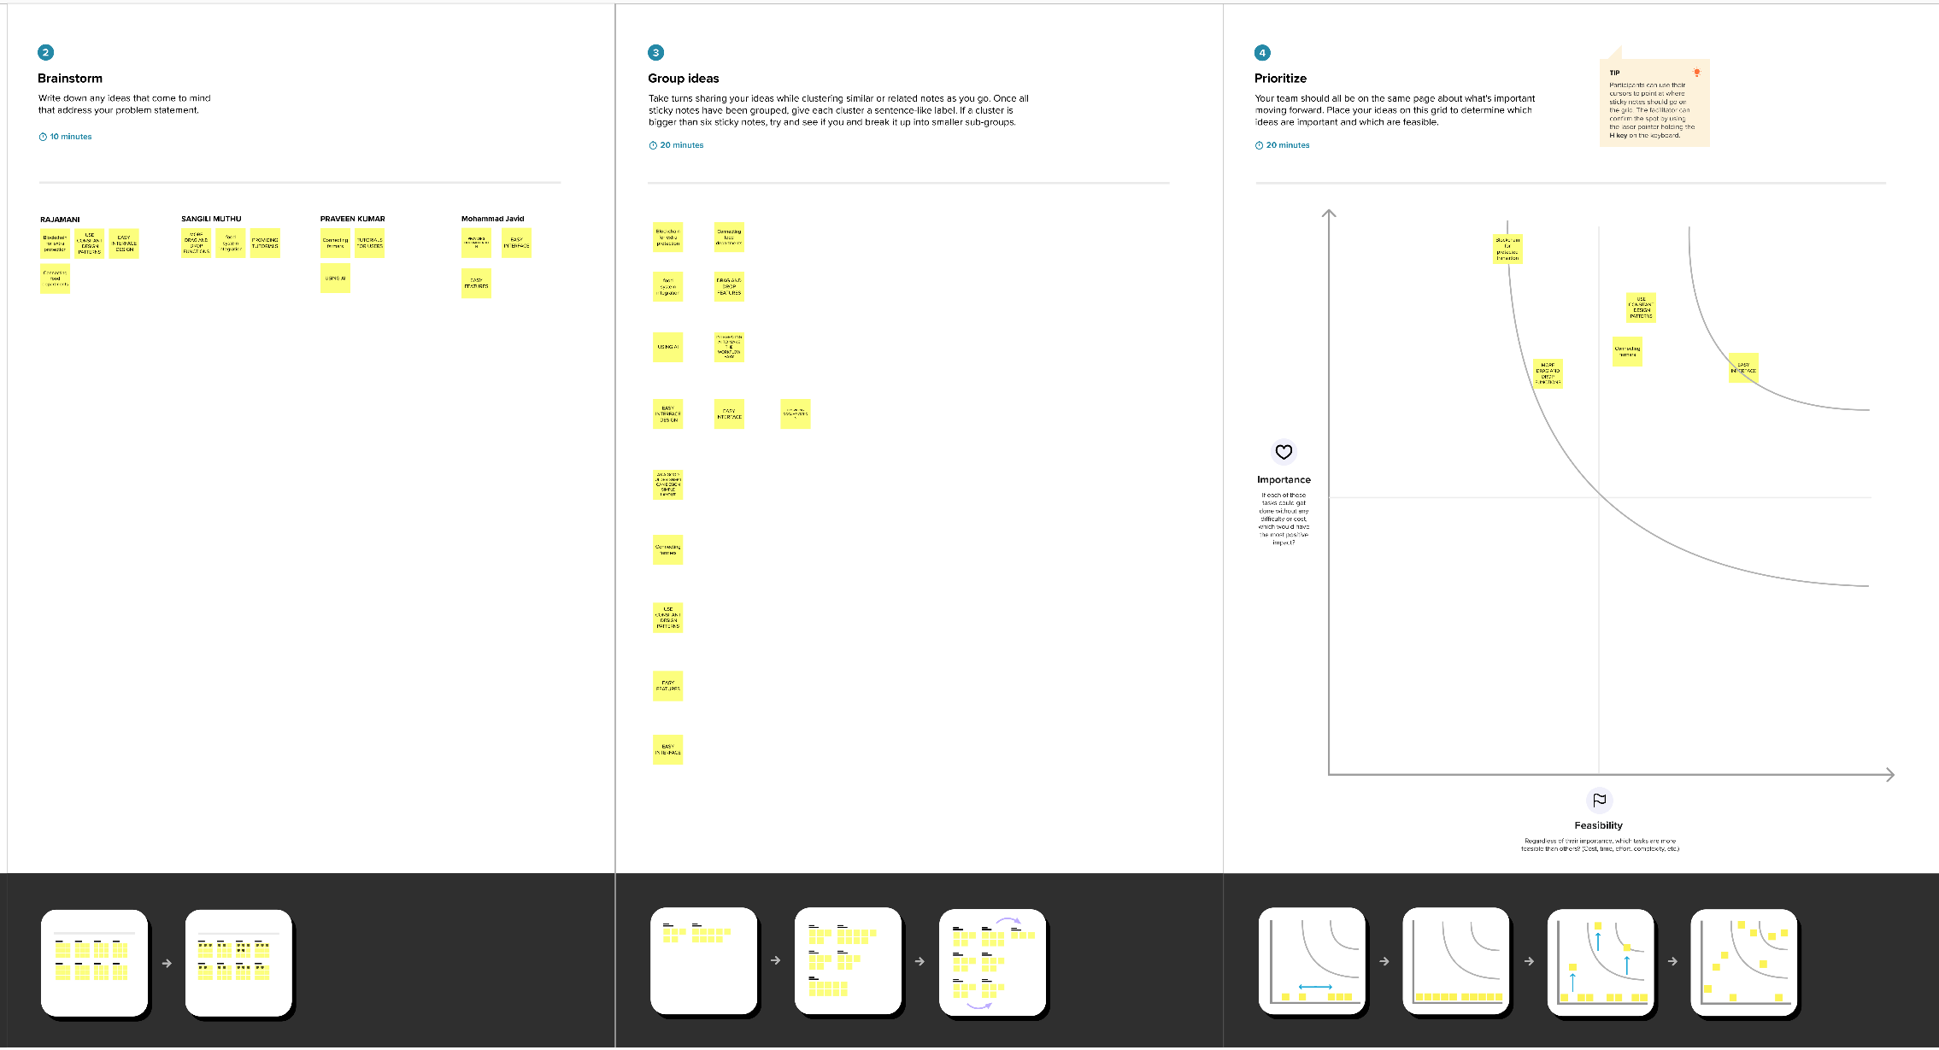

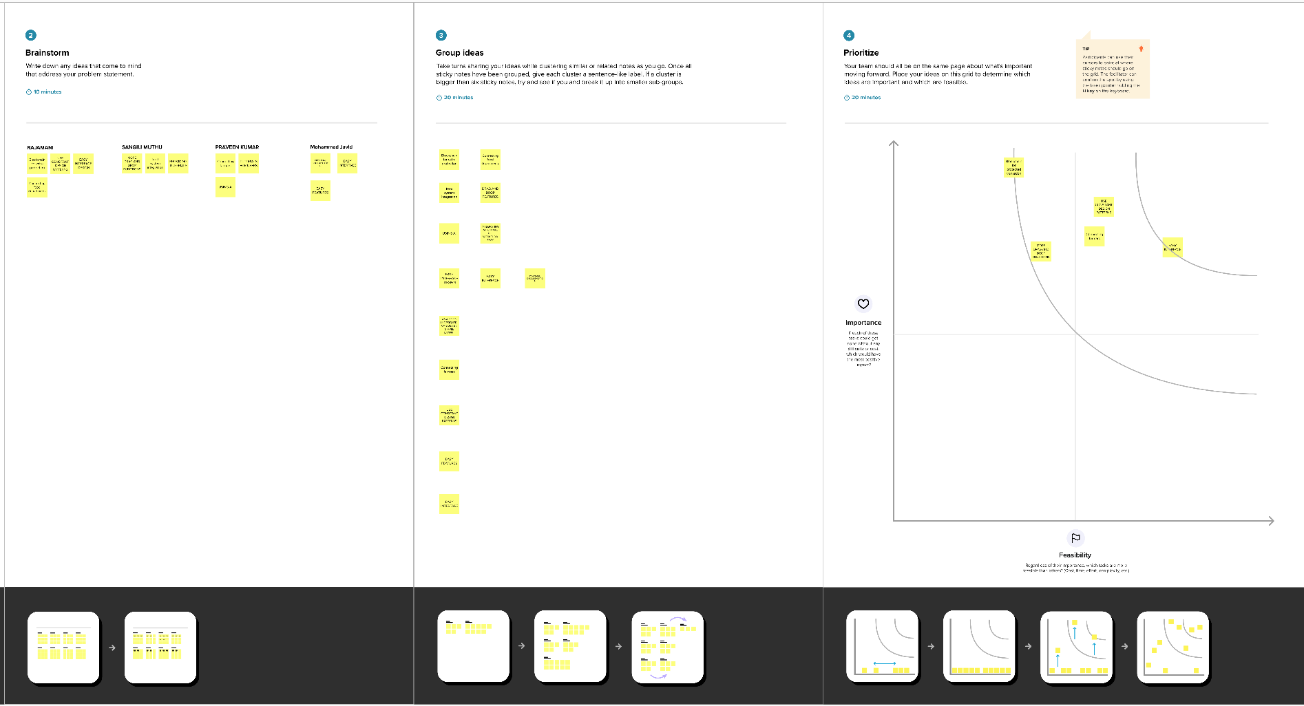

* **PROPOSED SYSTEM**

|  |  |  |
| --- | --- | --- |
| **S.No.** | **Parameter** | **Description** |
|  | Problem Statement (Problem to be solved) | The current food supply chain faces numerous challenges related to transparency, traceability, and food safety. Consumers and stakeholders in the food industry are often concerned about the origin and quality of the products they purchase. Foodborne illnesses, contamination, and fraud are persistent issues that erode trust in the food supply chain |
|  | Idea / Solution description | The food tracking system using blockchain is a holistic solution that promises to enhance transparency, traceability, and safety in the food supply chain, benefiting businesses, consumers, and regulatory bodies. It ensures that the journey of a food product is fully documented, helping to prevent foodborne illnesses, contamination, and fraud, ultimately leading to a more secure and trustworthy food supply chain. |
|  | Novelty / Uniqueness | The Food Tracking System Using Blockchain brings novelty and uniqueness through its effective use of blockchain technology's features, such as immutability and decentralization, coupled with real-time IoT data, automation, transparency, and consumer empowerment. It has the potential to revolutionize the food supply chain by improving consumer trust, safety, and efficiency while reducing fraud and errors. |
|  | Social Impact / Customer Satisfaction | the Food Tracking System Using Blockchain can have a profound social impact by improving food safety, empowering consumers, fostering trust and transparency, reducing food fraud, and promoting ethical and sustainable practices. As a result, it is likely to significantly enhance customer satisfaction and overall confidence in the food supply chain, benefiting both businesses and the public. |
|  | Business Model (Revenue Model) | It's important to adapt the revenue model to the specific needs and circumstances of food tracking system, considering the target audience, competitive landscape, and local regulations. The flexibility to combine multiple revenue streams can help create a sustainable and profitable business model for your blockchain-based food tracking system. |
|  | Scalability of the Solution | Scalability should be an ongoing consideration in the development and maintenance of your Food Tracking System Using Blockchain. By employing these strategies, you can address the challenges of handling a growing volume of transactions and participants while maintaining the system's performance and efficiency. |

* **REQUIREMENT ANALYSIS**

**Functional Requirements:**

|  |  |  |
| --- | --- | --- |
| **FR No.** | **Functional Requirement (Epic)** | **Sub Requirement (Story / Sub-Task)** |
| FR-1 | User Interface | * Create a user-friendly web or mobile application that allows participants and consumers to interact with the system, making it easy to input and access information   . |
| FR-2 | User Registration and Authentication | * Users, including farmers, distributors, retailers, and consumers, should be able to create accounts, log in, and authenticate themselves securely.   . |
| FR-3 | Data Privacy and Security | * Employ strong encryption and access control mechanisms to protect sensitive data and ensure compliance with data privacy regulations, such as GDPR |
| FR-4 | Permission Management | * Implement role-based access control to ensure that only authorized users can perform certain actions or access specific data. |
| FR-5 | Continuous Improvement | * Plan for regular updates and system improvements to adapt to technological advancements and changing regulations. |

**Non – Functional Requirements**

|  |  |  |
| --- | --- | --- |
| **FR No.** | **Non-Functional Requirement** | **Description** |
| NFR-1 | **Maintenance and Support** | * Provide ongoing maintenance, updates, and support for the system, addressing issues, and vulnerabilities promptly |
| NFR-2 | **Security** | * Data Encryption: Implement strong encryption techniques to protect sensitive data during transmission and storage on the blockchain. * Access Control: Enforce role-based access control to restrict unauthorized access to certain functionalities and data. |
| NFR-3 | **Reliability** | * The system must be highly reliable, with robust failover and backup mechanisms to ensure data integrity and accessibility. |
| NFR-4 | **Performance** | * Scalability: The system should scale horizontally and vertically to handle a growing number of participants and an increasing volume of transactions. * Response Time: Ensure that the system responds quickly to user actions, with minimal latency for data retrieval and transaction processing. |
| NFR-5 | **Availability** | * The system must be highly reliable, with robust failover and backup mechanisms to ensure data integrity and accessibility. |
| NFR-6 | **Data Backup and Recovery** | * Implement regular data backups and a robust disaster recovery plan to prevent data loss and ensure data can be restored in case of unforeseen events. |

**PROJECT DESIGN**

* **DATA FLOW DIAGRAM**

A Data Flow Diagram (DFD) is a traditional visual representation of the information flows within a system. A neat and clear DFD can depict the right amount of the system requirement graphically. It shows how data enters and leaves the system, what changes the information, and where data is stored.

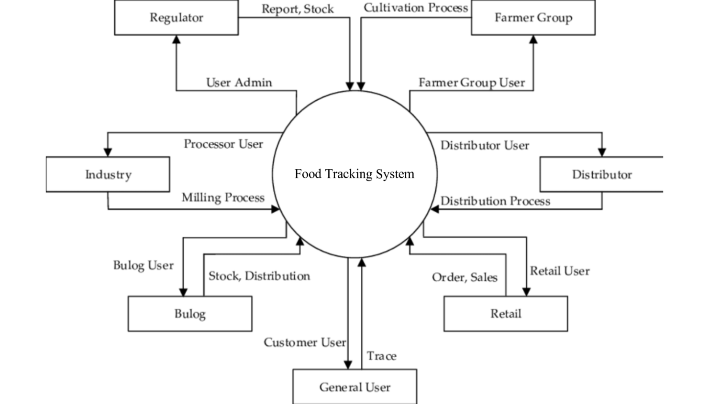

* **SOLUTION AND TECHNICAL ARCHITECTURE**

Solution architecture is a complex process – with many sub-processes – that bridges the gap between business problems and technology solutions. Its goals are to:

* Find the best tech solution to solve existing business problems.
* Describe the structure, characteristics, behaviour, and other aspects of the software to project stakeholders.
* Define features, development phases, and solution requirements.
* Provide specifications according to which the solution is defined, managed, and delivered.

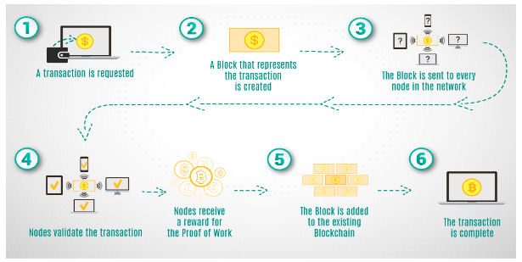

**CODING AND SOLUTIONS**

**code:**

// SPDX-License-Identifier: MIT

pragma solidity ^0.8.0;

contract FoodTracking {

address public owner;

enum FoodStatus {

Unverified,

Verified,

Consumed

}

struct FoodItem {

string itemId;

string productName;

string origin;

uint256 sentTimestamp;

FoodStatus status;

}

mapping(string => FoodItem) public foodItems;

event FoodItemSent(

string indexed itemId,

string productName,

string origin,

uint256 sentTimestamp

);

event FoodItemVerified(string indexed itemId);

event FoodItemConsumed(string indexed itemId);

constructor() {

owner = msg.sender;

}

modifier onlyOwner() {

require(msg.sender == owner, "Only contract owner can call this");

_;

}

modifier onlyUnconsumed(string memory itemId) {

require(

foodItems[itemId].status == FoodStatus.Verified,

"Item is not verified or already consumed"

);

_;

}

function sendFoodItem(

string memory itemId,

string memory productName,

string memory origin

) external onlyOwner {

require(

bytes(foodItems[itemId].itemId).length == 0,

"Item already exists"

);

foodItems[itemId] = FoodItem({

itemId: itemId,

productName: productName,

origin: origin,

sentTimestamp: block.timestamp,

status: FoodStatus.Unverified

});

emit FoodItemSent(itemId, productName, origin, block.timestamp);

}

function verifyFoodItem(string memory itemId) external onlyOwner {

require(

bytes(foodItems[itemId].itemId).length > 0,

"Item does not exist"

);

require(

foodItems[itemId].status == FoodStatus.Unverified,

"Item is already verified or consumed"

);

foodItems[itemId].status = FoodStatus.Verified;

emit FoodItemVerified(itemId);

}

function consumeFoodItem(

string memory itemId

) external onlyUnconsumed(itemId) {

foodItems[itemId].status = FoodStatus.Consumed;

emit FoodItemConsumed(itemId);

}

function getFoodItemDetails(

string memory itemId

)

external

view

returns (string memory, string memory, uint256, FoodStatus)

{

FoodItem memory item = foodItems[itemId];

return (item.productName, item.origin, item.sentTimestamp, item.status);

}

}

* **ADVANTAGES & DISADVANTAGES:**

**Advantages** of food tracking system using blockchain

**1.Enhanced Transparency:**

Immutable Ledger: Blockchain provides an immutable ledger that records every transaction and data point in the supply chain, making it nearly impossible to alter or tamper with records.

**2. Enhanced Traceability:**

With blockchain, it's easier to trace the origin of food products, including details such as where and when the food was produced, processed, and transported. This capability helps in quickly identifying and addressing issues like foodborne illnesses or recalls.

**3.Reduced Food Fraud:**

Blockchain can deter food fraud by ensuring that the data related to food products is accurate and cannot be tampered with. This reduces the chances of counterfeit products entering the market

**4. Supply Chain Efficiency:**

Blockchain technology streamlines the supply chain by providing a single source of truth for all stakeholders. This can lead to cost savings, reduced paperwork, and improved efficiency in logistics and inventory management

**5. Trust and Consumer Confidence:**

Consumers can access detailed information about the products they purchase, such as where the food comes from, its quality, and its ethical and sustainable practices. This transparency can increase consumer confidence in the food industry

**6.Decentralization and Security:**

Blockchain's decentralized nature ensures that no single entity has control over the data, making it less susceptible to data breaches or cyberattacks. This can enhance the security of food-related information

**Disadvantages** of food tracking system using blockchain:

**1.Complexity and Technical Barriers:**

Implementing a blockchain-based system can be complex and require a high level of technical expertise. Many participants in the food supply chain may not have the necessary knowledge or resources to adopt and maintain such a system

**2.Costs and Resource Intensity:**

Building and maintaining a blockchain system can be expensive, which may be a barrier for smaller producers or companies. It requires investments in technology, infrastructure, and ongoing maintenance

**3.Scalability Issues:**

Blockchain networks can experience scalability issues as more data is added to the chain. The technology may not handle the vast amount of data generated by the global food supply chain, leading to slower transaction speeds and increased costs.

**4.Data Privacy Concerns:**

Storing sensitive data on a blockchain could raise privacy concerns. While blockchain is designed to be secure and immutable, it can still be susceptible to data breaches or unauthorized access if not properly protected

**5.Regulatory and Legal Issues:**

The legal and regulatory framework surrounding blockchain technology is still evolving in many regions. Complying with these regulations can be complex and may vary from one jurisdiction to another.

**6.Standardization and Interoperability:**

Lack of standardized protocols and interoperability between different blockchain platforms can make it difficult for various stakeholders to work together effectively. This can hinder the adoption of blockchain in the food supply chain.

**7.Human Error and Data Input Issues:**

The accuracy of data on the blockchain depends on the information input by individuals at various points in the supply chain. Human error can lead to inaccurate or incomplete records

**CONCLUSION**

The Food Tracking System using Blockchain aims to revolutionize the food industry by ensuring transparency, security, and efficiency throughout the supply chain. It benefits all stakeholders and contributes to a safer and more trustworthy food ecosystem. The use of blockchain technology is pivotal in achieving these goals, and its potential for further advancements in food tracking and safety is substantial..

* **Wider Adoption**

The adoption of blockchain in the food industry is expected to grow significantly as more stakeholders recognize the benefits of transparency and traceability. This includes not only large-scale producers but also smaller and local food producers.

* **Interoperability:**

Efforts to standardize and improve the interoperability of different blockchain platforms and systems will likely increase, making it easier for various parties in the food supply chain to collaborate effectively.

* **IoT Integration:**

The integration of Internet of Things (IoT) devices with blockchain can provide real-time data on food products' conditions, such as temperature and humidity during transport and storage. This ensures the integrity and quality of the food.

* **AI and Machine Learning:**

The use of artificial intelligence and machine learning can enhance data analysis, making it easier to identify patterns and trends in the supply chain and predict issues related to food safety and quality.

* **Mobile Applications**

User-friendly mobile apps for consumers and businesses could make it simple for people to access blockchain-based information about the food products they purchase. Consumers can scan QR codes or use apps to verify product authenticity and origin

* **Blockchain Consortiums:**

Industry-specific consortia and collaborations may become more common, bringing together various stakeholders to develop and implement blockchain solutions that benefit the entire supply chain.

* **Integration with Existing Systems:**

Efforts to simplify the integration of blockchain with existing legacy systems and databases will expand, making it easier for companies to adopt the technology.

**Source Code :** [6_Problem_Statement_6_Food_Tracking.zip - Google Drive](https://drive.google.com/file/d/1DDrs9A0ZW2Z-pCQKF0CiwW83FUo1_5Xr/view)

**DEMO VIDEO LINK :** <https://drive.google.com/file/d/19SXU8wL5W8yFORD9-u5WR5ZLLFdgPEHE/view?usp=sharing>

**GITHUB LINK :** <https://github.com/REVANTH-2003/Nm-Blockchain-Powered-Library-Management>